Organic scintillators
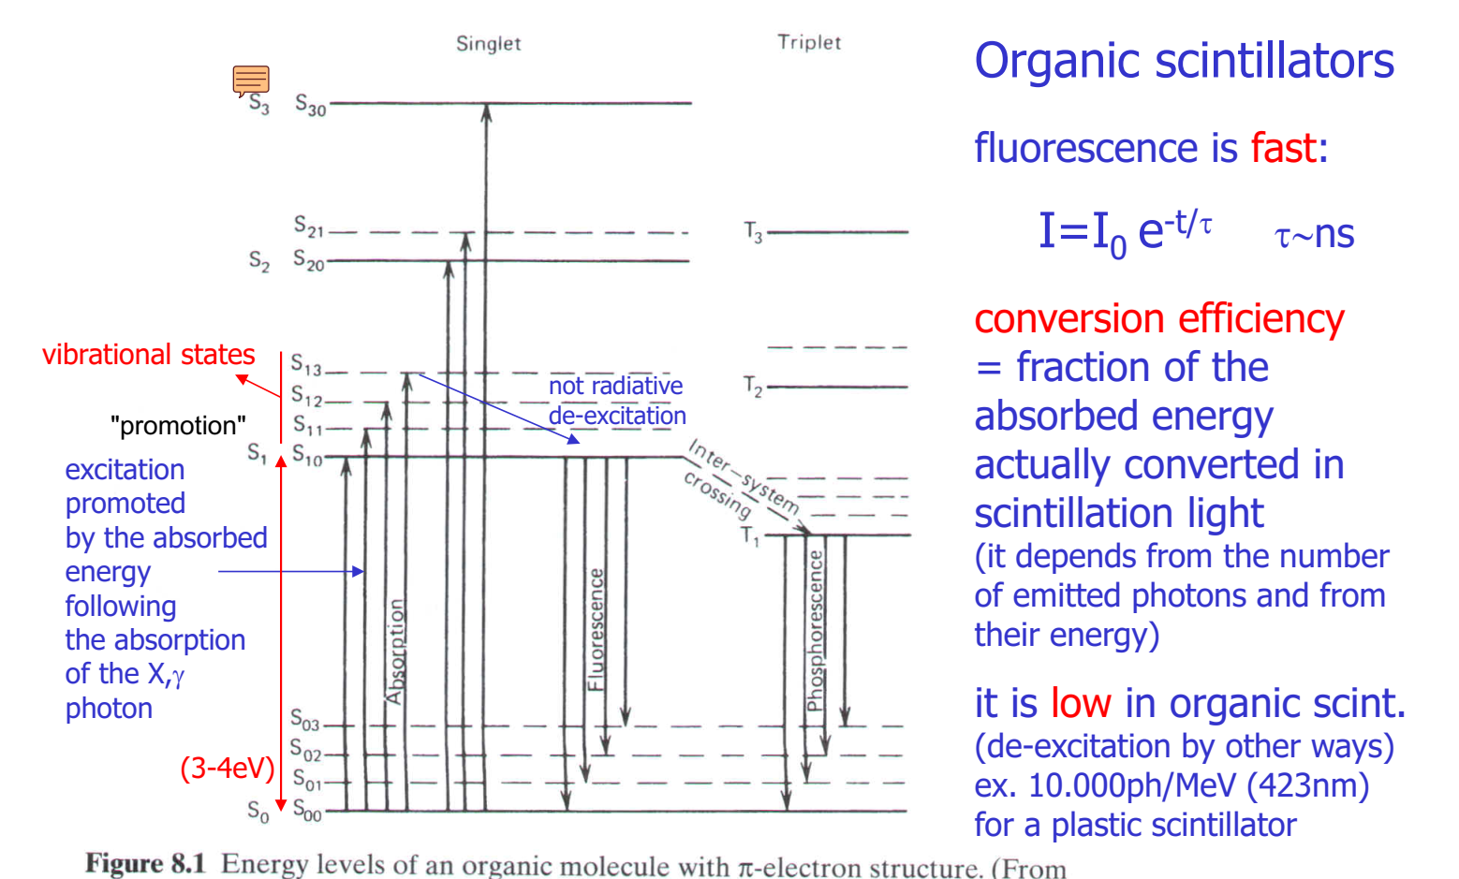
We can have:
- ORGANIC (plastic) SCINT
  - Fast
  - Low efficiency
- INORGANIC (crystals) SCINT
  - Slow
  - Efficient
Depending on the material.
Organic: not bands, energy levels of the molecule. Ground state of the molecule, and then exited state of molecule. More mols together don’t form crystals with en. bands, we still keep the en. levels.
1) absorbed gamma ray
2) ejection of the electron (in the case of a semiconductor - direct conversion mat. - the ray produces ionization, creating el/holes pairs. In this case we have an insulator, it doesn’t produce charges).
3) the electron goes around the material, and each site of interaction with the material promotes the excitation of one molecule. We actually have several promotions.
4) they go back to ground state by the emission of an optical photon. IT'S A FLUORESCENCE PHENOMENA! (if it's delayed.. phosforescence. not good for us, creates afterglow).
Typical time descriptors of a scintillator. (Common also for inorganic):
1° PARAMETER: VELOCITY
Rising of the pulse it's almost instantaneous. But not all scintillation photons are emitted instantaneous, we have a temporal decay! After 5, 6 tau the process is over. Important: tells us how quick is the scintillator.
Organic are VERY FAST, almost a delta! MAIN PROPERTY of organic.
2° PARAMETER: EFFICIENCY:
fraction of absorbed energy released as energy of the photons.
The energy of a scintillator photons is "hv". Take photons, make the sum of hv, this is the overall energy of the emitted scint. photons. We have the E0 of absorbed g-ray.
So Eph/E0 = efficiency.
!!!! not actually used! actually used: NUMBER OF PHOTONS, CONVERSION GAIN.
G = n.photons/E0. [n.photons/keV]
“numero di fotoni emessi per energia”. [Nella conversion diretta avevamo il “costo” che era energia/coppia_e-h. Ricordando la tabella c’era anche CsI+PMT che faceva 23. Infatti serviva anche la parte PMT per fare elettroni. Se consideriamo SINGOLARMENTE lo scintillator, allora l’efficienza dipenderà dai fotoni emessi per energia. Cioè, una sorta di costo (in realtà efficienza) però per avere fotoni (anche se è inverso.. ).
ofc, more photons the better. we use this b/c photons carries a different energy. if we have different emission wavelengths they'll carry different energy :(. At the end, at the P.D., for him 1 photon is 1 electron/hole pair!!!! (it's actually a little worse with quantum efficiency..).
Praticamente: non ha senso considerare l’energia emessa, perché una volta che il fotodetector detecta un fotone, lui genera cariche ,quindi la differenza di en. Non la percepisce. Perciò si valuta il numero di fotoni emessi.
So we don't care if the photon has different energy. So we can have an index independent from the wavelength. :) PERO’ LA CONSIDERO PER LO SCINTILLATOR: LUI PIU’ ENERGIA RICEVE PIU’ FOTONI PRODUCE!
DISADVANTAGE OF PLASTIC SCINT:
LOW CONV.
10^4 ph/MeV

